

American International University-Bangladesh (AIUB)

**Department of Computer Science**

**Faculty of Science &Technology (FST)**

**Spring 2020-2021**

**CSC 2210 Object Oriented Analysis and Design (OOAD)**

**Section: [K]**

**Group No: 01**

**PROJECT TITLE**

Library Management System

**Object-Oriented Analysis and Design (OOAD) project**

By

|  |  |  |
| --- | --- | --- |
| SL No | Student Name | Student ID |
| 1 | Shakibur Rahman | 20-43820-2 |
| 2 | Shek Iftier Islam | 20-43757-2 |
| 3 | Navid Mahfuz Nayeem | 20-42354-1 |
| 4 | Rishat Ryan | 20-42137-1 |
| 5 | Asif Khan | 20-43075-1 |

**CHAPTER 1: PROBLEM DOMAIN**

**Abstract:**

With this project, a library can be managed without any hesitation or having to worry about books go missing. With this library management system, there will be records of users and librarians both. Librarians or users can easily access books or remember their accessed books history with this application project which might be helpful.

**1.1 Background Information**

The library management system is a software system that issues books and magazines to registered users only. User has to login after getting registered to the system. Users must have a card. The Borrow history will also be shown to the user. The borrower of the book can perform various functions such as searching for desired book, get the issued book and return the book. Library management system helps libraries keep track of the books and their checkouts, as well as student profiles.

The library management system also includes maintaining database for entering new books and keeps record of the books that have been borrowed or bought with their respective due dates.

Library Management System can be a good use for Libraries because of various reasons. Some library owners often complaint that some people steal books from them or don’t return books by the due time. It becomes difficult to keep record of each and everyone.

Problem Statement:

A library is a place where all kinds of book, magazines are displayed, and people can easily access to these items and can borrow books if they have membership. Because the library is an open space for book readers and students, there are some problems which can’t be resolved without having a software-based system. One of the most unavoidable problems librarians’ faces is books getting stolen from library. Some people borrow books but don’t return it in due time. A library management system-based application can resolve the problem that is faced by the librarians. This system will be able to keep records of all users. In this case, if someone doesn’t return book in due time, he or she will have to pay fine. This system will keep records of books too. So, in any case if books go missing, the librarian can check records and will be able to identify who stole or didn’t return the book.

Objectives And Scope:

The main objective of creating the document about the software is to know about the list of the requirements in the software project part of the project to be developed. It specifies the requirement to develop a processing software part that completes the set of requirements. The cores of objectives of the project are followings:  
  
1.Access to all sorts of books.  
2. Keeping track of orders and fines.  
3. Storing book borrow/buy history

**1.2 Proposed Solution:**

To deal with the problem some solutions are given below :

1. Any student will have access to search books by the title, author, subject category.

2. Each book will have a unique identification number which will ease locating books.

3. There could be more than one copy of a book, and library members should be able to check out and reserve any copy.

4. There should be a maximum limit on how many books a student can check-out.

5. If any student doesn’t return a book after due date, system should be able to keep record of the student and collect fines.

6. Members should be able to reserve books that are not currently available.

7. The System should be able to retrieve information like who took a particular book or what are the books checked-out by a specific library member.

This might be a proper solution to solve the problem as librarians can easily keep book records and borrow history of each member and it can also help managing a library easily because of technology.

Here the software which is being specified is Library Management System. In this project we’ve illustrated that how Library Management System Works and its process step by step through Use Case diagram, Class diagram, Sequence diagram, State chart diagram and Activity diagram.

Now the purpose, including relevant benefits and goals is given below:

Purpose: The purpose of this project is to develop an object-oriented model for Library Management System

Benefits:

1.This project will portray the Library Management System

2.It will have a user interface that can easily be used by user to borrow or buy books.

3.The borrowed or bought books record will be kept.

4.User level interface.

Goals: Library Management System is an interface between the users and a database that can be use It targets at improving the overall management section of a library and ease the complexities

**Chapter 2: UML DIAGRAM**

**2.1 Use Case Diagram:**

A use case is a list of actions or events. Steps typically defining the interactions between a role and a system to achieve a goal. The use case diagram consists of various functionalities performed by actors like librarian and user.

Case Study:

A user first login into his account. He can renew his borrowed books. besides he can search for books. A librarian can also do the above work. A user can Return his books. But a librarian can add books, he can also delete some books. Moreover, he can edit book tag names.

A librarian can buy books via e commerce sites to add library. He can payment via bkash or Card. After all activities user and librarian can logout form the portal

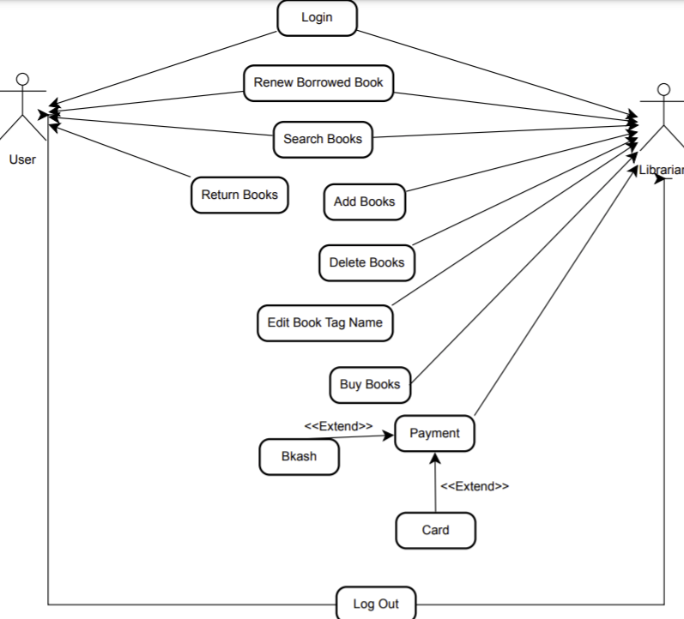

Fig: Use Case Diagram

**2.2 Class Diagram:**

A class diagram in the unified modeling language is a type of static structure diagram that describes the structure of a system by showing the system’s classes, their attributes, operations and the relationships among objects.

Case Study:

A library has many kinds of books. User login into their account and borrow books. User has two part, Staff and students. One user have one account. in the account section users see the history. A library has one or more librarian. A library has a central database. database have add, delete, update features. A librarian has permission to access database. User and librarian both search books. Books are organized by Tittle and Unique code. User can borrow and refund books. A Librarian verify Users before issue books.

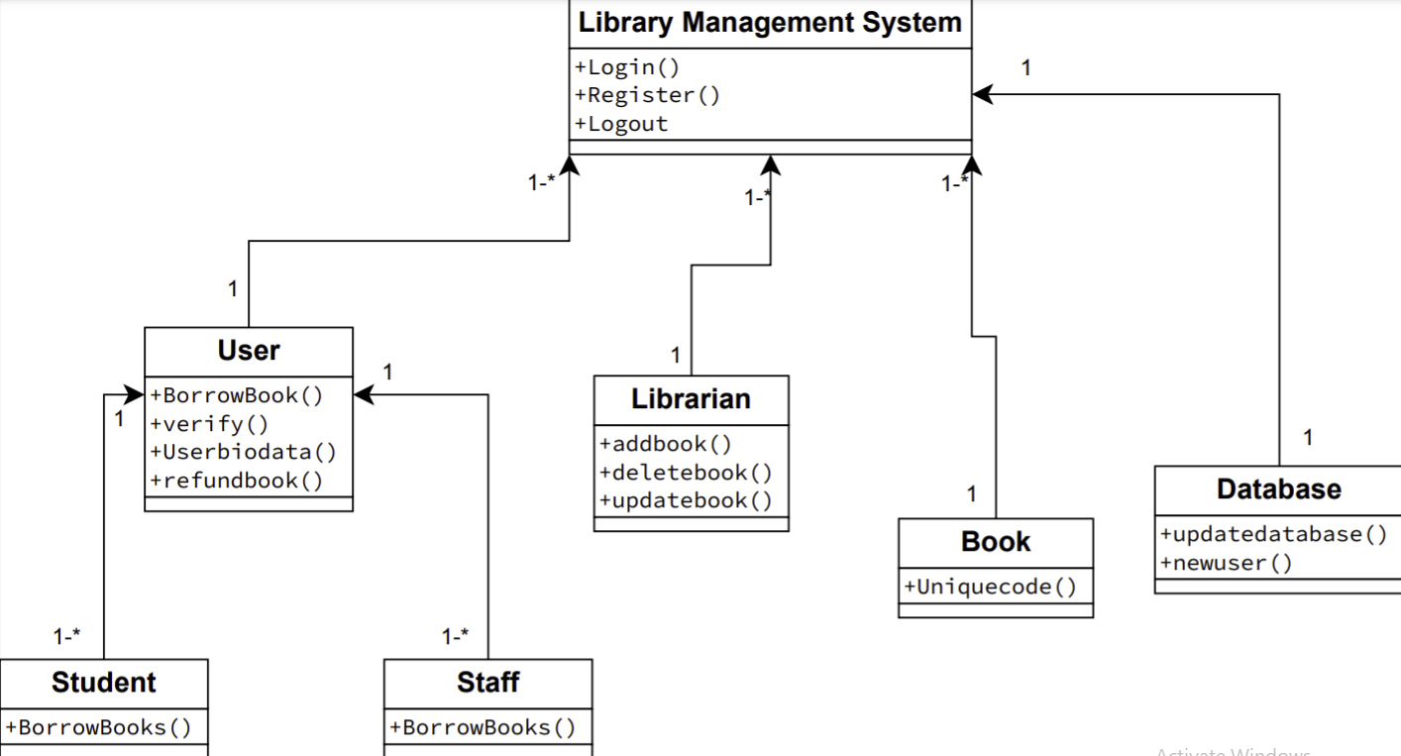

Fig: Class Diagram

**2.3 Sequence Diagram:**

A sequence diagram represent the sequence and interactions of a given use case or scenario. Sequence diagram capture most of the information about the system. It is also represented in order by which they occur and have the object in the system send message to one another. Here the sequence starts with interaction between user and the system followed by database.

Case Study:

In the management system of a university a member can place a request to book a journal to the librarian. Before the librarian can complete the booking that member has to be verified of his status whether he is allowed to borrow journals or not. The journal then has to be located whether it is in the campus where the request was made or it is in a different campus. If the journal is in a different campus the librarian makes a request for the journal to be sent at the requested campus. The librarian then informs the member about the time required for the journal to reach and completes the booking.

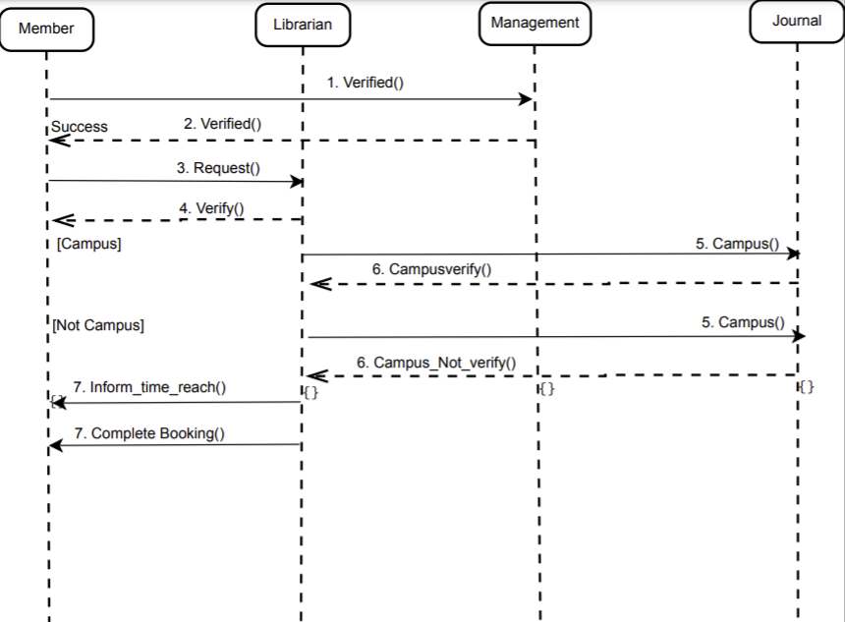

Fig : Sequence Diagram

**2.4 State Chart Diagram:**

State chart diagram is also called as state machine diagram. The state chart diagram contains states in the rectangular boxes and the states are indicated by the dot enclosed. The state chart diagram describes the behavior of the system.

Case Study:

To use the library system at first, the reader have to login with his pin. After entering, it will be verified by matching with system records. If it’s verified, if the reader previously borrowed books, he can return it and then he can check the book or only can check books. If the reader find his searched book then can borrow the book. He also gains membership by paying 3 Dollars. Then he will be a regular member of a library.

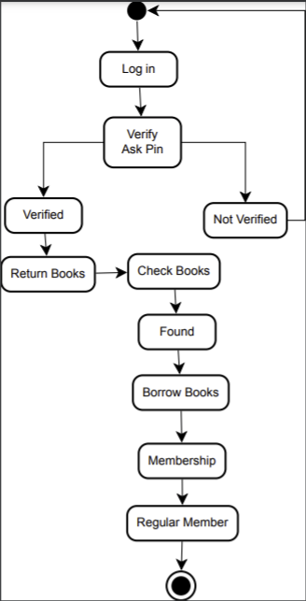

Fig : State Chart Diagram

**2.5 Activity Diagram:**

Activity diagrams are graphical representation of workflows of stepwise activities and actions with support for choice, iteration, and concurrency. Here in the activity diagram the user logs in to the system and performs some main activity which is the main key element to the system.

Case Study:

User first logs in his account. System can verify his id card. User request to check borrowed history. Then the system shows borrowed history. Then the user returns previous borrowed books. Then check the books. Besides System show books. He can borrow 1 or more books. Then he will log out from this system.

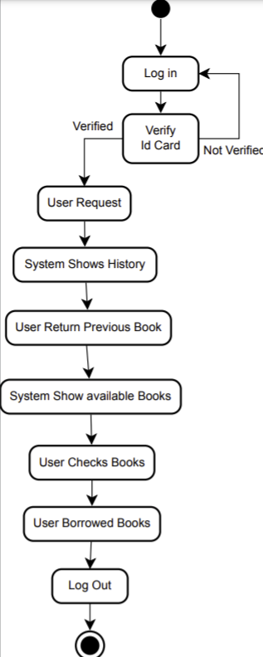

Fig: Activity Diagram

**Prototype**:

Login Form:

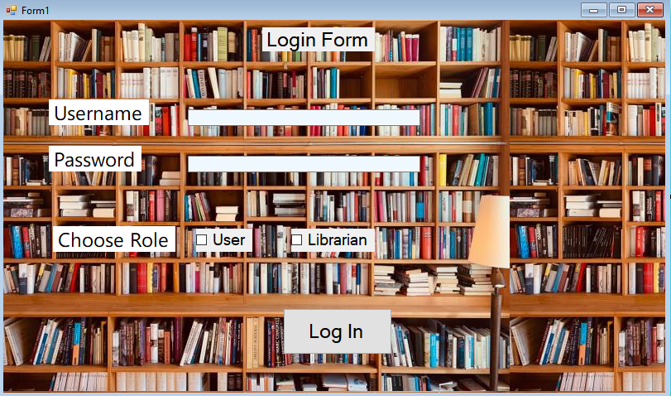

Student Menu:

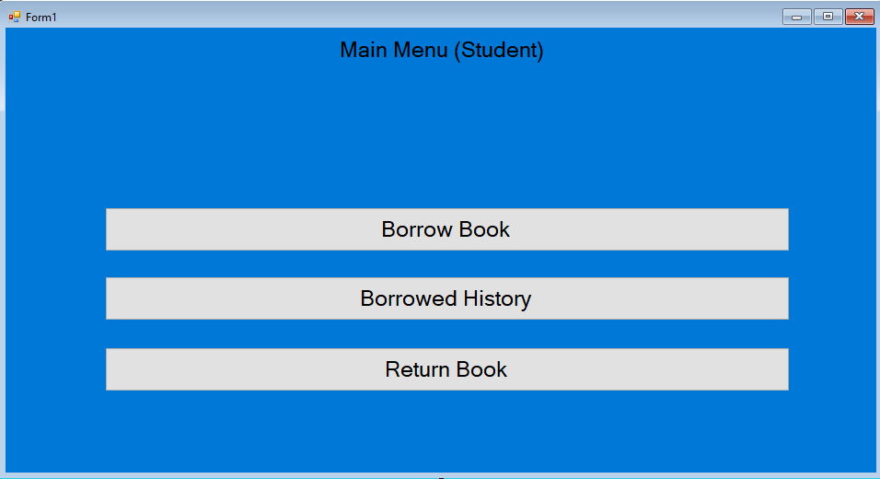

Student Borrow Book Menu: -

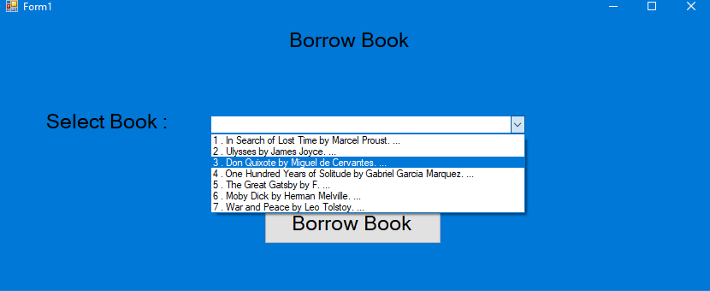

Student Return Book Menu: -

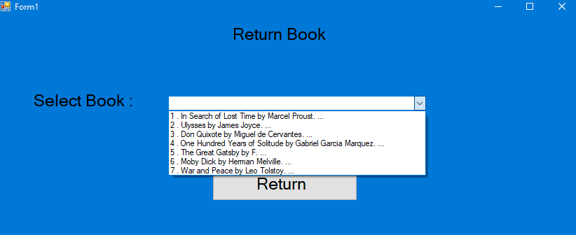

Student Books Borrow History: -

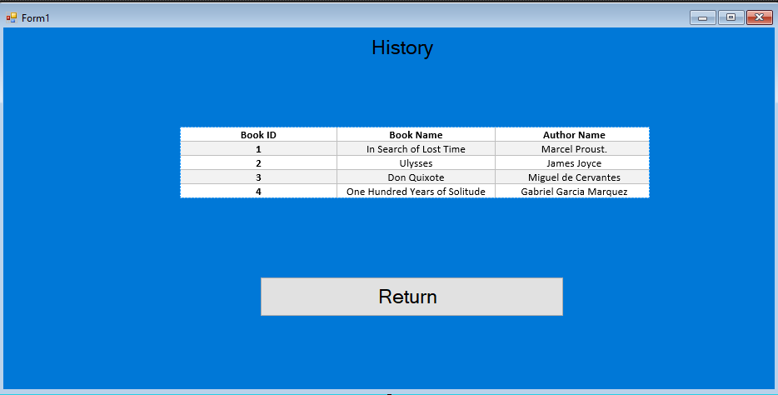

Logged In as Librarian: -

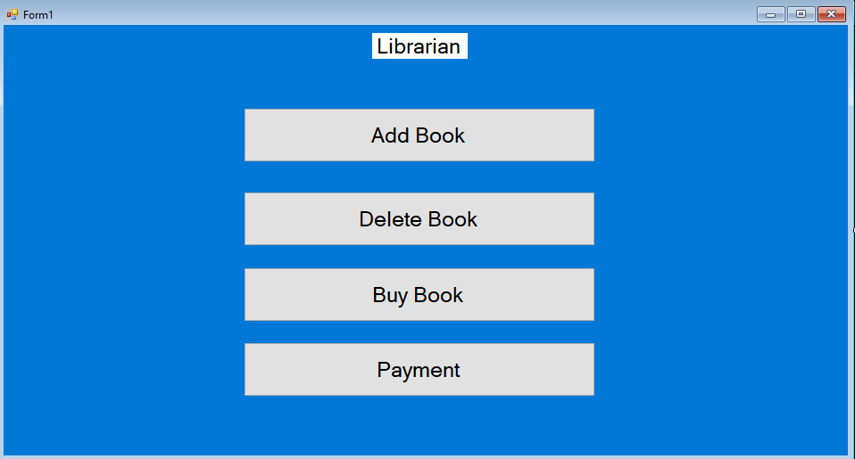

Librarian Add/Delete Book Menu

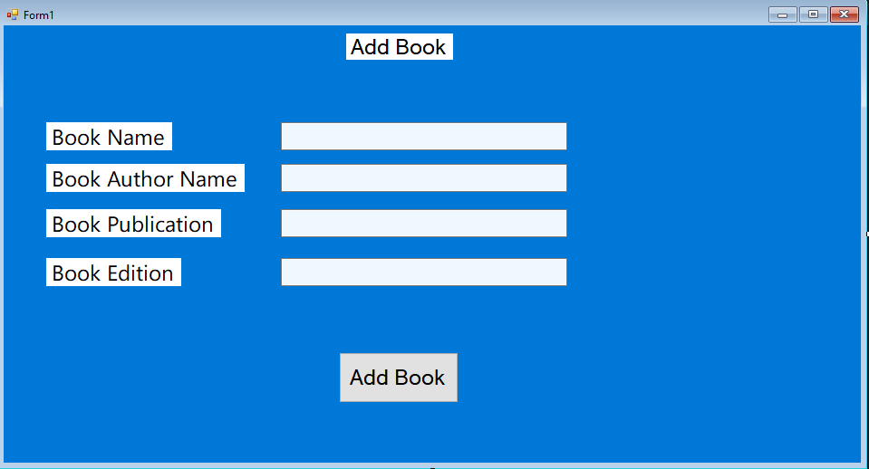

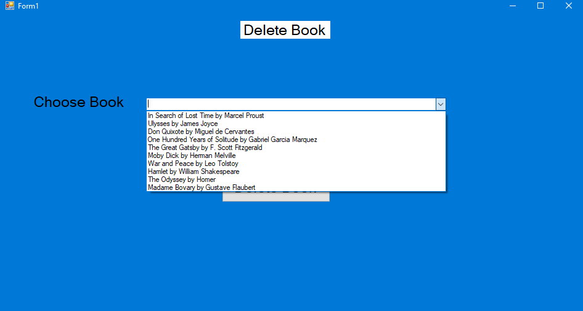

Librarian Buy Book Menu:-

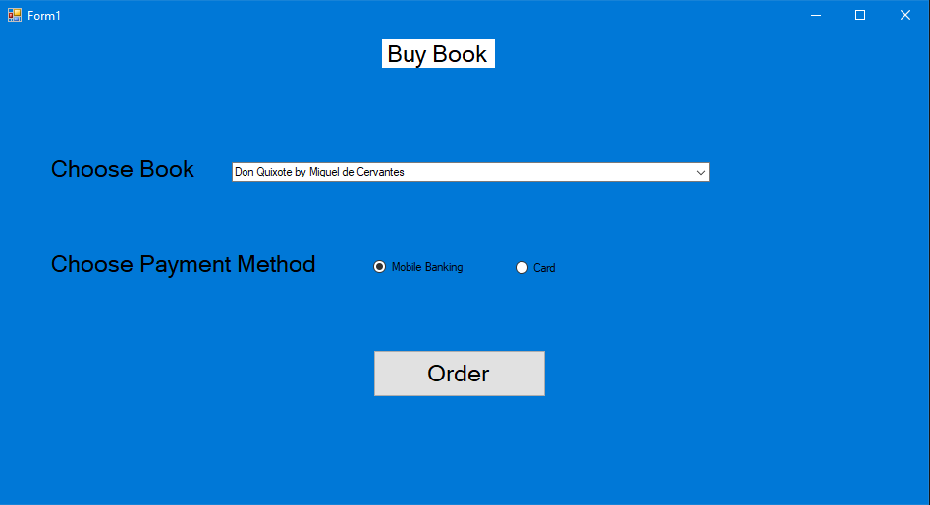

Librarian Payment Method:-

